November List
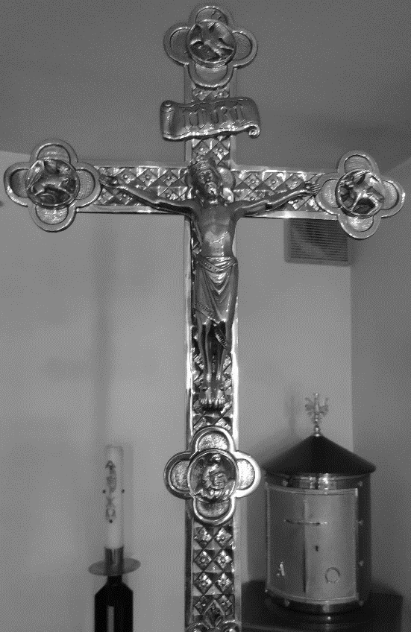
Remember also, Lord, your servants who have gone before us with the sign of faith and rest in the sleep of peace. Grant them, O Lord, we pray, and all who sleep in Christ, a place of refreshment, light and peace. Through Christ our Lord. Amen.
Eternal rest grant unto them, O Lord, and let perpetual light shine upon them.

